SYDNEY WESTERN CITY PLANNING PANEL

Panel Number: | PPSSWC-123
Application Number: | 2020/1012/1
Local Government Area: | Camden.
Development: | Demolition of existing structures and construction of three (3) residential flat buildings comprising 115 apartments with basement car parking, landscaping, road construction, drainage works, servicing and associated site works.
Capital Investment Value: | $30,067,529
Site Address(es): | 47 Ingleburn Road, Leppington
Applicant: | Ajay Parasher
Owner(s): | 47 Developments Pty Ltd
Date of Lodgement: | 16 December 2020
Number of Submissions: | Nil
Number of Unique Objections: | Nil
Classification: | Regionally significant
Recommendation: | Refuse.
Regional Development Criteria (Schedule 7 of State Environmental Planning Policy (State and Regional Development) 2011): | General development capital investment value >$30 million.
List of All Relevant Section 4.15(1)(a) Matters: | - State Environmental Planning Policy (State and Regional Development) 2011.  - State Environmental Planning Policy (Sydney Region Growth Centres) 2006.  - State Environmental Planning Policy (Infrastructure) 2007.  - State Environmental Planning Policy No 55 - Remediation of Land.  - State Environmental Planning Policy No 65 – Design Quality of Residential Apartment Development.  - State Environmental Planning Policy (Building Sustainability Index: BASIX) 2004  - Sydney Regional Environmental Plan No 20 - Hawkesbury-Nepean River.  - Camden Growth Centre Precincts Development Control Plan.  - Apartment Design Guide.
List all Documents Submitted with this Report for the Panel’s Consideration: | - Assessment report.  - SEPP / DCP assessment tables.  - Apartment Design Guide assessment table.  - Applicant’s written request seeking to justify the contravention of a development standard.  - Proposed plans.
Development Standard Contravention Request(s): | State Environmental Planning Policy (Sydney Region Growth Centres) 2006.  Clause 4.3 - Maximum building height.
Summary of Key Submission Issues: | No submissions were received.
Report Prepared By: | Adam Sampson, Executive Planner.
Report Date: | 26 March 2021.

Summary of Section 4.15 Matters

Yes
Have all recommendations in relation to relevant Section 4.15 matters been summarised in the Executive Summary of the assessment report?

Legislative Clauses Requiring Consent Authority Satisfaction

Yes
Have relevant clauses in all applicable environmental planning instruments where the consent authority must be satisfied about a particular matter been listed and relevant recommendations summarised in the Executive Summary of the assessment report?

Development Standard Contraventions

 | Yes | N/A
If a written request for a contravention to a development standard has been received, has it been attached to the assessment report?

Special Infrastructure Contributions

 | Yes | No
Does the application require Special Infrastructure Contributions?

Conditions

 | Yes | No
Have draft conditions been provided to the applicant for comment?

PURPOSE OF REPORT

The purpose of this report is to seek the Sydney Western City Planning Panel’s (the Panel’s) determination of a development application (DA) for a residential flat building development at 47 Ingleburn Road, Leppington.

The Panel is the consent authority for this DA as the capital investment value (CIV) of the development is $30,067,529. This exceeds the CIV threshold of $30 million for Council to determine the DA pursuant to Schedule 7 of State Environmental Planning Policy (State and Regional Development) 2011.

SUMMARY OF RECOMMENDATION

That the Panel determine DA/2020/1012/1 for a residential flat building development pursuant to Section 4.16 of the Environmental Planning and Assessment Act, 1979, by way of refusal for the reasons outlined at the end of this report.

EXECUTIVE SUMMARY

Council is in receipt of a DA for a residential flat building development at 47 Ingleburn Road, Leppington.

The DA has been assessed against the Environmental Planning and Assessment Act 1979, the Environmental Planning and Assessment Regulation 2000, relevant environmental planning instruments, development control plans and policies.

A summary of the assessment of all relevant environmental planning instruments is provided below with a detailed assessment provided later in the report.

State Environmental Planning Policy (State and Regional Development) 2011. | The Panel is the consent authority for this DA as the development has a CIV of $30,067,529 which exceeds the CIV threshold of $30 million for Council to determine the DA.
State Environmental Planning Policy (Sydney Region Growth Centres) 2006 (Growth SEPP). | The development is permitted with consent in the R3 Medium Density Residential zone. However, the DA contravenes the maximum height of buildings development standard and does not provide sufficient information demonstrating that public utility infrastructure that is essential for the proposed development is available or that adequate arrangements have been made to make that infrastructure available when required.
State Environmental Planning Policy (Infrastructure) 2007 (ISEPP). | The DA was referred to Transport for NSW for comment pursuant to the ISEPP and the comments received have been considered.
State Environmental Planning Policy No. 55 – Remediation of Land. | A preliminary site investigation report was submitted with the application and has been considered by Council staff.  Twenty-six soil samples were collected from the site, with no contamination detected. In addition, no imported fill or asbestos was found on site. As such, Council staff are satisfied that no remediation is required in this instance and that the site is suitable for the development.
State Environmental Planning Policy No. 65 – Design Quality of Residential Apartment Development. | The development is inconsistent with the Design Quality Principles and does not meet the objectives and design criteria of the Apartment Design Guide.
State Environmental Planning Policy (Building Sustainability Index: BASIX) 2004 | The submitted BASIX Certificate is inconsistent with the development plans in respect to car parking (162 spaces specified, however only 158 spaces exist on the plan) and the proposed roof site coverage stated upon the architectural plans conflicts with the BASIX stated roof area.
Sydney Regional Environmental Plan No 20 - Hawkesbury-Nepean River (SREP 20). | The development is consistent with the aim of SREP 20 (to protect the environment of the Hawkesbury-Nepean River system) and all of its planning controls.

The DA was publicly exhibited for a period of 14 days in accordance with Camden Development Control Plan 2019. The exhibition period was from 14 to 27 January 2021 and no submissions were received.

The applicant has submitted contradictory road design plans for the southern local street, with one plan indicating half width road construction and another plan indicating full width road construction, which will require owners consent from the adjoining southern neighbour. No evidence of adjoining owner’s consent has been submitted with the application. In respect to the half width road design plan submitted, the plan contains errors and appears to be positioned further north noting the existence of pedestrian ramps providing access to building block E within the road reserve.

The applicant has provided insufficient information to satisfy the requirements of Camden Growth Centre Precincts Development Control Plan in relation to water cycle management (Clause 2.3.2); salinity and soil management (Clause 2.3.3); Native vegetation and ecology (Clause 2.3.5); noise (Clause 2.3.9); earthworks (Clause 2.6); layout and design (Clause 3.3.1); temporary vehicular access (Clause 3.3.5); access to arterial roads, sub-arterial roads and transit boulevards (Clause 3.3.6); and landscaped area (Clause 4.3.5 Table 4-10). In addition, the application fails to comply with side setback, proposing a setback of 3m in part to the eastern property boundary in lieu of 6m as required under the DCP.

Based on the assessment, it is recommended that the DA be refused for the reasons outlined at the end of this report.

KEY PLANNING CONTROL VARIATIONS

Standard | Proposed | Contravention
12m (maximum building height) | 14.4m | 2.4m (20%)

AERIAL PHOTO

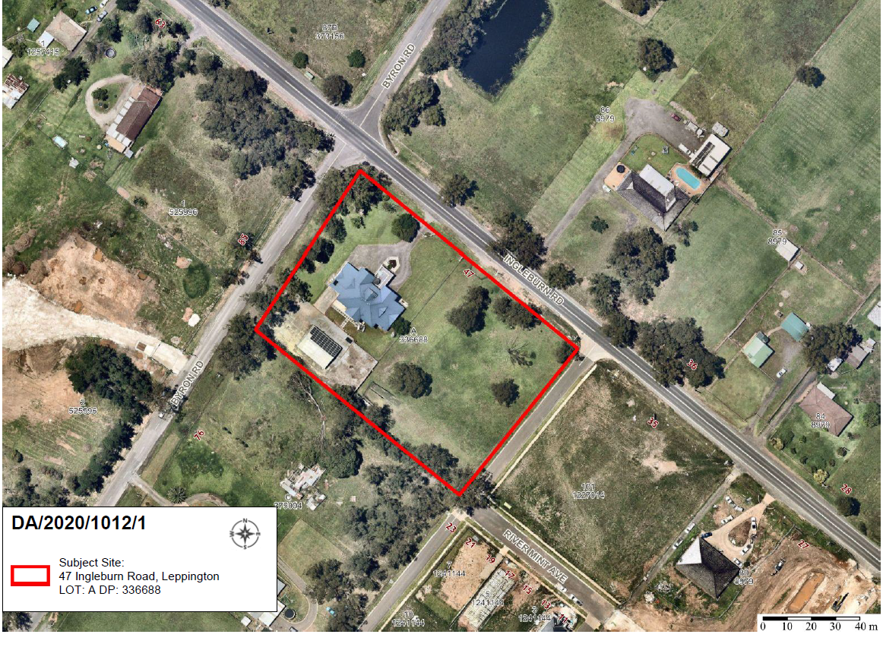

THE SITE

The site is commonly known as 47 Ingleburn Road, Leppington and is legally described as Lot A DP 336688 and has an overall area of 8,708.2m².

The site is rectangular in shape and is located on the southern side of Ingleburn Road. The site has a frontage of 115.715 metres to Ingleburn Road and a frontage of 78.105 metres to Byron Road. The land has a cross fall from the rear of the site towards the north west. The development site is located within the Leppington Priority Precinct of the South West Growth Centre.

The site currently contains a two storey white rendered dwelling house and several detached outbuildings. The site is predominately clear of vegetation with a scattering of vegetation located upon the eastern side of lot. A row of trees line Byron Road within the road reserve.

The surrounding area is characterised by undulating topography, scattered vegetation, dams, market gardens and poultry farms which is transitioning from rural residential to residential development.

To the north of the site, opposite Ingleburn Road, detached rural – residential properties exist.

To the east, a residential subdivision development exists with new local roads and detached dwellings being constructed. Development consent has been granted for a part three and part four storey residential flat building to be erected at 35 Ingleburn Road, Leppington (to the immediate east of the development site), however construction works have yet to commence.

To the south, large dwellings and large outbuildings exist on large land holdings on adjoining properties, with further new residential subdivision development consisting of new local roads and new dwellings occurring further to the south and south west.

To the west opposite Byron Road, a State Significant Development (SSD 9227) was granted consent for the construction and operation of a new school (Amity College) in eight stages, to accommodate up to 1,000 students. Earthworks have commenced on that site.

ZONING PLAN

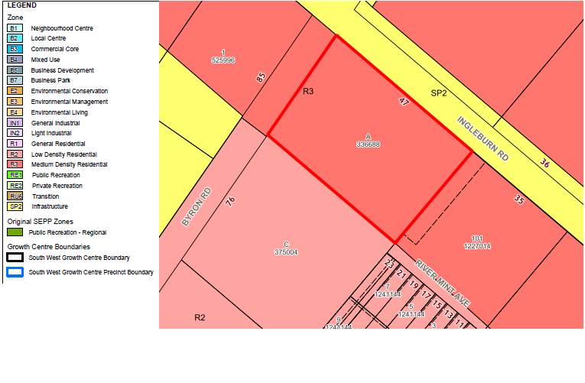

Indicative Layout Plan (Leppington Priority Precinct)

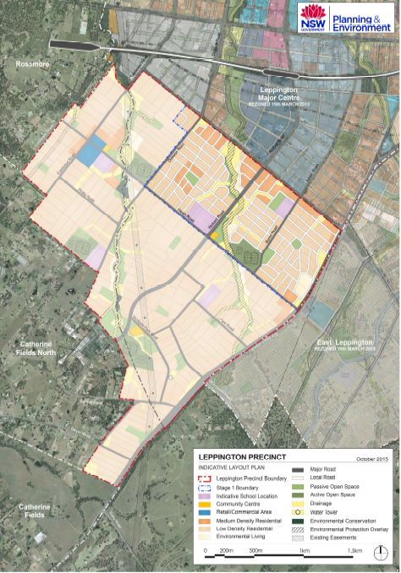

HISTORY

The relevant development history of the site is summarised in the following table:

Date | Development
2 August 2020 | DA/2018/1499/1 for the demolition of existing structures, removal of trees, construction of a residential flat building development containing three buildings and a total of 148 apartments, and associated site works was withdrawn.

THE PROPOSAL

DA/2020/1012/1 seeks approval for the construction of a residential flat building development.

Specifically, the development involves:

- Construction of three (3) x four (4) storey residential flat buildings and a singular level of basement parking, for 115 units comprising, 4 x 1 bedroom units, 71 x 2 bedroom units and 40 x 3 bedroom units:

- A single level basement carpark providing 158 car spaces;
- Building A & B (western end of site) – consisting of 38 residential units;
- Building C (central building) - consisting of 41 residential units;
- Building D & E (eastern end of site) - consisting of 36 residential units;
- A roof terrace atop Building block D adjacent to Ingleburn Road.

- Road construction along the southern property boundary. (Note: contradictory road design plans have been submitted for the southern local street, with one plan indicating half width road construction and another plan indicating full width road construction over the southern adjoining property).

- Associated site works, including drainage and landscaping.

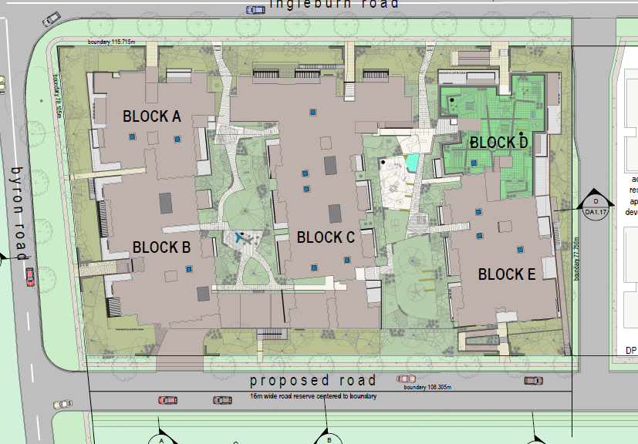
Image 1 – Site Plan

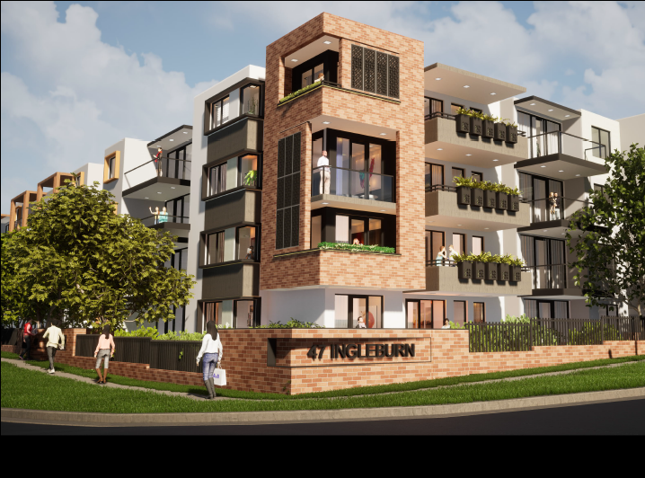
Image 2 – Corner perspective of Building A at the intersection of Ingleburn Road and Byron Road

PANEL BRIEFING

Council staff briefed the Panel on the DA on 3 March 2021. The following discussion provides a response to the matters raised by the Panel

- The Panel notes that the proposed development appears to exceed the height limit by at least 2.4 metres at its highest point. Strong justification for this contravention will be needed given the fact that the site is unconstrained and plays an important transition area between the future Leppington Town Centre and lower density residential homes. Overall, the Panel will need to be fully satisfied that the development provides for an appropriate transition to the lower density residential area being developed to south and east of the site and in surrounding areas.

Council Comment

The applicant has submitted a clause 4.6 written request that seeks to justify the contravention of the maximum height of buildings development standard. The maximum height sought by the development is approximately 14.4m upon building D, however all buildings exceed the standard, with height exceedances ranging from 400mm to 2m upon building A, B, C and E.

Having regard to the matters for consideration under Clause 4.6 of the SEPP it is assessed that the objectives of Clause 4.6(1) have not been met as a better outcome for and from the development has not been achieved in this instance.

Pursuant to Clause 4.6(4) of the SEPP, it is considered that the applicant’s written request has not adequately addressed the matters required to be demonstrated by Clause 4.6(3) of the SEPP and that the proposed development will not be in the public interest because it is inconsistent with the objectives of the height of buildings standard. This matter is discussed further within this report.

The built form of buildings B, C and E is proposed to stand four storeys (with height exceedances) and fails to respond and provide an effective height transition down to the lower density R2 Low Density Residential zone to the south (on the opposite side of the local street) which has a maximum building height of 9m.

A three storey wall height (that complies with the height of buildings development standard) adjoining the future local street is considered a more appropriate design outcome (i.e. transition) and would allow a more pedestrian friendly streetscape.

The proposal at present fails to create a responsive street-wall height along the proposed local street to the south that takes into account the pedestrian scale and likely height of future development across the road.

The proposed development is inconsistent with the desired built form adjoining the R2 Low Density Residential zone interface. To this extent it is noted that the development to the east (DA/2017/709/1 - 35 Ingleburn Road, Leppington) that was approved by the Land and Environment Court created an effective height transition by concentrating the four storey development at the front of the site with three storeys at the rear of the site.

- There are a number of other issues which will need to be fully addressed in relation to this proposal:

- Inconsistency with road design plans and the need for adjoining owner’s consent for the 16m road design proposed by the applicant, including clarity over whether the road width will be shared;
- Implications of the Ingleburn Road Concept Design which anticipates future road widening along Ingleburn and Byron Roads, necessitating redesign of the building form and basement;
- The design quality and amenity of the development, having regard to SEPP 65 and the Apartment Design Guide; noting a number of apparent inconsistencies relating to the quantity and quality of communal open space, which appears significantly overshadowed; natural ventilation and solar access to apartments; maximum room depths and minimum room dimensions; balcony design, overlooking, and visual privacy. There are also concerns about the external appearance of the development, including considerable expanses of blank walls along the southern elevation.
- Whether the site can accommodate the proposed density (equivalent to approximately 130 dwellings per hectare), noting that the Growth Centres SEPP specifies only a minimum density band for the site of 25 dwellings per hectare, and noting the height and apparent ADG inconsistencies outlined above.

Council Comment

Inconsistency between road design plans

The applicant has submitted contradictory road design plans for the southern local street, with one plan indicating half width road construction and another plan indicating full width road construction, which will require owners consent from the adjoining southern neighbour at 76 Byron Road, Leppington. The precinct road hierarchy plan requires a 16m wide local street, with the road width to be shared by 47 Ingleburn Road and the southern adjoining neighbour at 76 Byron Road as per the Indicative Layout Plan. In respect to the half width road design plan submitted, the plan contains errors and appears to be positioned further north, noting the existence of pedestrian ramps providing access to building block E within the road reserve. The applicant has failed to acknowledge or address the conflicting road design plans.

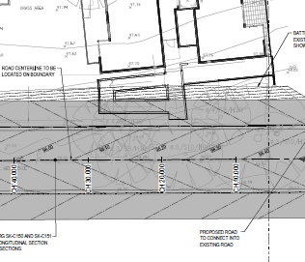
Image 3 – Proposed half road construction containing plan errors

Future Upgrade of Ingleburn Road

The proposed development has failed to consider the Ingleburn Road Concept Design that was provided to the applicant and discussed throughout assessment of DA/2018/1499/1.

Increased setbacks are required to both street frontages to accommodate future road / intersection upgrades in the precinct. As per image 4 below, it is evident that significant design changes are required to ensure that the proposed development does not conflict with the future Ingleburn Road upgrade.

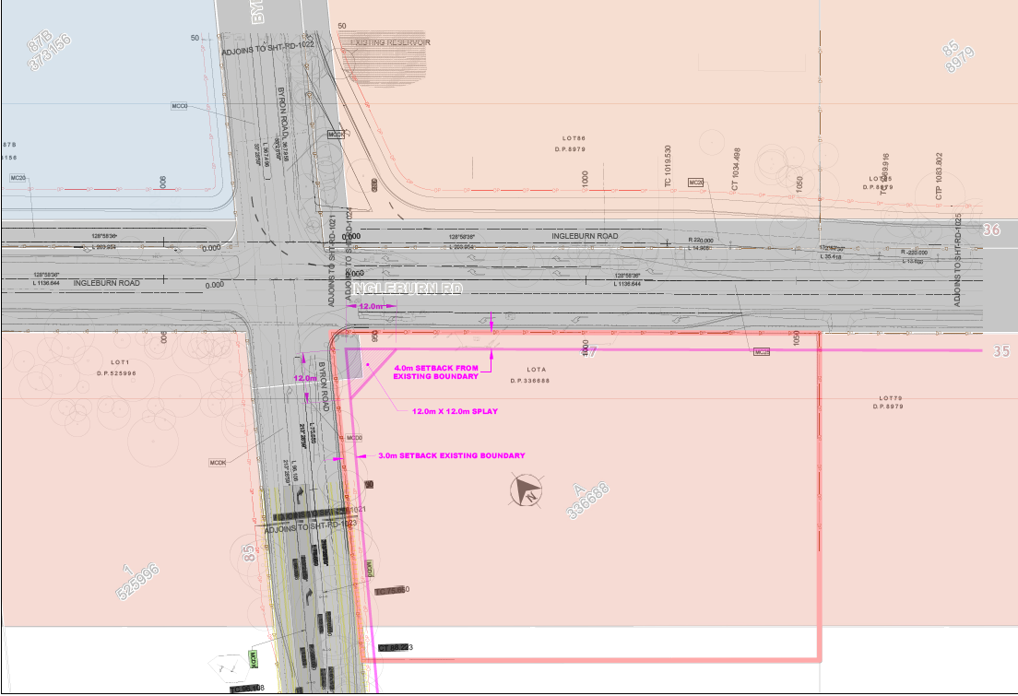
Image 4 – ACOR design overlay of required future acquisition along Ingleburn and Byron Road.

The design quality of the development

A copy of the assessment of the proposed development against the design criteria of the Apartment Design Guide (ADG) is provided as an attachment to this report, with assessment of the application revealing several inconsistencies with the ADG and the design quality principles, which will result in poor amenity being achieved.

Critically, the development is inconsistent with the following design criteria of the ADG:

- 3B-1 Orientation
- 3C-1 Public domain interface
- 3D-1(2) Communal and public open space
- 3E-1 Deep soil zones
- 3F-1 Visual privacy
- 3G-1 Pedestrian access and entries
- 3H-1 Vehicle access
- 4A-1 Solar and daylight access
- 4B-1 Natural Ventilation
- 4D-2(2) & 4D-3(1&2) Apartment size and layout
- 4E-1 Private open space and balconies
- 4J – Noise and pollution

Density

The proposed development seeks to provide approximately 115 dwellings per hectare, with the minimum density being 25 dwellings per hectare as per State Environmental Planning Policy (Sydney Region Growth Centres) 2006 (SEPP)(Appendix 9).
Based on the issues identified in this assessment report, including the contravention of the maximum height of buildings development standard; significant overshadowing of the principal usable part of ground level communal open space areas; inappropriate street wall height adjacent to the new local street; non-compliant side setbacks; insufficient building separation; and natural ventilation requirements unlikely to be met, it is considered that the proposed density is not appropriate for the site.

ASSESSMENT

Environmental Planning and Assessment Act 1979 - Section 4.15(1)

In determining a DA, the consent authority is to take into consideration such of the following matters as are of relevance to the development the subject of the DA:

(a)(i) the provisions of any environmental planning instrument

The environmental planning instruments that apply to the development are:

- State Environmental Planning Policy (State and Regional Development) 2011.
- State Environmental Planning Policy (Sydney Region Growth Centres) 2006.
- State Environmental Planning Policy (Infrastructure) 2007.
- State Environmental Planning Policy No 55 - Remediation of Land.
- State Environmental Planning Policy No 65 - Design Quality of Residential Apartment Development.
- State Environmental Planning Policy (Building Sustainability Index: BASIX) 2004.
- Sydney Regional Environmental Plan No 20 - Hawkesbury-Nepean River.

State Environmental Planning Policy (State and Regional Development) 2011 (SRD SEPP)

The SRD SEPP identifies development that is State significant or regionally significant development.

The Panel is the consent authority for this DA as the CIV of the development is $30,067,529. This exceeds the CIV threshold of $30 million for Council to determine the DA pursuant to Schedule 7 of the SRD SEPP.

State Environmental Planning Policy (Sydney Region Growth Centres) 2006 (Growth SEPP)

The Growth SEPP aims to co-ordinate the release of land for residential, employment and other urban development in the North West Growth Centre, the South West Growth Centre and the Wilton Growth Area.

Site Zoning

The site is zoned R3 Medium density residential pursuant to Appendix 9, Clause 2.2 of the Growth SEPP.

Land Use Definitions

The development is defined as a “residential flat building” by the Growth SEPP.

Permissibility

The proposed development is permitted with consent in the zone in which it is proposed pursuant to the land use table in Appendix 9 of the Growth SEPP.

Planning Controls

An assessment table in which the development is considered against the Growth SEPP’s planning controls is provided as an attachment to this report.

Proposed Contravention

The applicant proposes a contravention to the height of buildings development standard that applies to the site.

The development standard limits buildings to a maximum height of 12m above natural ground level. The development will have a maximum height of approximately 14.4m above finished ground level, but the contravention relates to several areas of the development, including the built form, parapet and roof, clerestory and skylight windows and lift overruns.

The breach of building height applies to all buildings on site, with the northern, eastern and western facades exceeding the maximum building height approximately from 700mm up to 1.6m. It should be noted that there are no natural ground levels indicated in the architectural plans (i.e. elevations) to determine the true extent of the height of the development.

Contravention Assessment

Pursuant to Appendix 9, Clause 4.6(3) of the Growth SEPP, the applicant has submitted a written request that seeks to justify the contravention of the development standard.

In summary, the applicant’s written request provides the following justification for the contravention:

- the development is consistent with the objectives of the development standard and does not create any significant environmental impacts. Consequently, strict compliance with the development standard is unnecessary as the development meets the objectives of the LEP.

- The elements that generate the non-compliance are a series of elements that form part of the roof and include parts of the roof. These areas would be perceived as any other roof element and do not obstruct any views for adjoining properties. Importantly given the skillful architectural design these elements would not either be seen from the streetscape or not dominate the streetscape.

- The proposed development is mostly compliant with the maximum building height of 12 metres prescribed by the Growth Centres SEPP. The main building forms that exceed the height limit are the parts of the roof to each block, lift overruns, skylights and roof communal open space balustrade.

- The non-complying elements do not cause any loss of sunlight and do not strike any windows whereby an adverse impact would be generated. Moreover, the proposal generates a good quality design outcome for the subject site.

- The development is not out of character and not inconsistent with proposed future development in the area. The proposal is consistent with the future desired character under the objectives of the R3 Medium Density Residential land use zone.

- The non-complying elements form part of the roof structure. These elements balance the overall design of the proposal and through a skillful design ensures that these elements do not dominate the streetscape. Further, these elements do not obstruct any views from surrounding properties.

- Pursuant to the decision in Initial Action Pty Ltd V Woollahra Municipal Council [2018] NSWLEC 118 it need not be demonstrated that the non-complying development has a “neutral or beneficial effect relative to a compliant development”. Should the design be amended to comply, it would cause an inferior design and planning outcome with no better environmental outcome. Accordingly, the proposal is optimal as it stands.

A copy of the applicant’s written request is provided as an attachment to this report.

Council Staff Assessment

Having regard to the matters for consideration under Clause 4.6 of the SEPP it is assessed that the objectives of Clause 4.6(1) have not been met as a better outcome for and from the development has not been achieved in this instance.

Pursuant to Clause 4.6(4) of the SEPP, it is considered that the applicant’s written request has not adequately addressed the matters required to be demonstrated by Clause 4.6(3) of the SEPP and that the proposed development will not be in the public interest because it is inconsistent with the objectives of the Height of buildings development standard.

Council staff have reviewed the Clause 4.6 written request and recommend that it be not supported for the following reasons:

- The development does not satisfy the objective of Clause 4.3(1)(b) Height of buildings – ‘to minimise visual impact and protect the amenity of adjoining development and land in terms of solar access to the buildings and open space’, as the proposed continuous four (4) storey street wall is not an acceptable streetscape presentation and does not fulfill the desired future character of the area.

- The development does not satisfy the objective of Clause 4.3(1)(c) Height of Buildings – ‘to facilitate higher density development in and around commercial centres and major transport routes’, as the proposed development and increased density as a result of height contravention is located on the periphery of the Town Centre and is not within walkable distance to the centre to support the proposed higher density development.

- The built form of Building B, C and E up to four storeys with height exceedances, fails to respond and provide an effective height transition down to the lower density R2 Low Density Residential zone to the south of future local residential street that has a maximum height standard of 9m.

- The proposed skylights and clerestory windows which breach the maximum building height standard do not satisfy natural ventilation requirements of the ADG and are therefore unnecessary breaches to the standard. In lieu, the number of apartments with natural cross ventilation rather than secondary sources ought to be maximized.

- It has not been demonstrated that the additional height will result in a better outcome for the site, noting that the development substantially overshadows both communal open space areas at ground level.

- Compliance with the development standard has not been adequately demonstrated to be unreasonable or unnecessary in the circumstances of the case.

- Sufficient environmental planning grounds to justify contravening the height of buildings development standard have not been adequately addressed in this instance.

Council has the assumed concurrence of the Director General of the Department of Planning and Environment. In this regard, the contravention of the development standard does not raise any matter of significance for State or regional environmental planning. To the extent that there is any public benefit in maintaining the development standards, as the development has not satisfied the objectives of Clause 4.6(1), it is considered that there is public benefit in this instance in maintaining the development standard.

Consequently, it is recommended that the Panel do not support the proposed contravention to the SEPP’s maximum building height development standard.

State Environmental Planning Policy (Infrastructure) 2007 (ISEPP)

The ISEPP aims to facilitate the effective delivery of infrastructure across the State.

Transport for NSW (TfNSW)

The DA was referred to TfNSW for comment pursuant to Clause 104 of the ISEPP as, pursuant to Schedule 3 of the ISEPP, the development is classed as traffic generating development.

TfNSW has reviewed the application and advises that further information is required to sufficiently assess the application. TfNSW has requested that the impact of the proposed development on the intersection of Camden Valley Way and Ingleburn Road, including current and future year scenarios (with and without development) be assessed. SIDRA modelling and results would be required to demonstrate intersection performance.

State Environmental Planning Policy No. 55 - Remediation of Land (SEPP 55)

The SEPP requires the consent authority to be satisfied that the site is suitable for its intended use (in terms of contamination) prior to granting consent.

A preliminary site investigation report was submitted with the application and has been considered by Council staff.

Twenty-six soil samples were collected from the site, with no contamination detected. In addition, no imported fill or asbestos was found on site. As such, Council staff are satisfied that no remediation is required in this instance and that the site is suitable for the development.

Should the application be approved, a hazardous building assessment will be required for the existing dwelling and structures on site. In addition, a standard contingency condition that requires any contamination found during construction to be managed in accordance with Council's Management of Contaminated Lands policy should also be imposed.

State Environmental Planning Policy No. 65 – Quality Design of Residential Apartment Development (SEPP 65)

SEPP 65 aims to improve the design quality of residential apartment development and provides an assessment framework, the Apartment Design Guide, for assessing ‘good design’.

The SEPP requires consideration of any Development Application for residential accommodation meeting the application criteria of the SEPP against the nine (9) design quality principles, including the advice obtained from a design review panel and the Apartment Design Guide (ADG).

A copy of the assessment of the proposed development against the design criteria of the ADG is provided as an attachment to this report, with assessment of the application revealing several inconsistencies with the ADG and the design quality principles.

It is considered that the development does not have adequate regard to the design quality principles and lacks an understanding of the future desired character of the precinct. The development is considered to have an inappropriate built form and street wall height, particularly to the south, with the proposed design uniform, repetitious and monotonous, resulting in a bulky form being presented to the street.

The development creates poor amenity for future residents as a result of design orientation, which results in significant overshadowing of both ground level communal open space areas, poor landscaping and deficient room sizes and private open space areas. In addition, the development fails to maximise the number of apartments with natural cross ventilation, with single aspect units compromised by acoustic impact from Ingleburn and Byron Roads.

The proposed development has been assessed against the SEPP’s design quality principles:

Principle 1: Context and Neighbourhood Character – Non compliant

The entire area is undergoing a significant transition from rural/rural residential, to an urban character. In consideration of the proposed built form and establishing the future character of Leppington, building height and length coupled with street wall height are essential to create a desired streetscape.

The built form of buildings B, C and E is proposed to stand four storeys, with height exceedances and fails to respond and provide an effective height transition down to the lower density R2 Low Density Residential zone to the south of the future local street that has a maximum height standard of 9m. A three storey wall height (that complies with the building height standard) adjoining the future local street would allow a more pedestrian friendly streetscape and an appropriate transition down to the adjoining lower density development within the R2 Low Density Residential zone.

The proposal at present fails to create a responsive street-wall height along the proposed local road to the south that takes into account the pedestrian scale and likely height of future development across the road.

The proposed development is inconsistent with the desired built form adjoining the R2 Low Density Residential zone interface. To this extent it is noted that the development to the east (DA/2017/709/1 - 35 Ingleburn Road, Leppington) that was approved by the Land and Environment Court created an effective height transition by concentrating the four storey development at the front of the site with three storeys at the rear of the site.

Principle 2: Built Form and Scale – Non compliant

The orientation of proposed buildings results in a large amount of shadow to the proposed principal usable part of ground level communal open space areas based on the shadow diagrams in the architectural package.

The proposed buildings significantly overshadow the principal usable part of the communal open space areas, whereby it does not receive more than 50% direct sunlight for a period of at least 2 hours between 9am and 3pm on 21 June.

The southern elevation facing the future local street is visually poor, with large expanses of blank walls, which do not activate this road frontage and offer limited visual interest to the street.

Principle 3: Density – Non compliant

The proposed development seeks to provide approximately 115 dwellings per hectare, with the minimum density being 25 dwellings per hectare as per State Environmental Planning Policy (Sydney Region Growth Centres) 2006 (SEPP)(Appendix 9).

Based on the issues identified in this assessment report, including the contravention of the maximum height of buildings development standard; significant overshadowing of the principal usable part of ground level communal open space areas; inappropriate street wall height adjacent to the new local street; non-compliant side setbacks; insufficient building separation; and natural ventilation requirements unlikely to be met, it is considered that the proposed density is not appropriate.

Principle 4: Sustainability – Non compliant

The proposal does not satisfactorily demonstrate that natural cross ventilation can be achieved, with the development proposing several single aspect units. It is noted that the submitted acoustic report has failed to include predicted noise levels based on the ten-year forecast traffic for Ingleburn and Byron Road as required by Camden Growth Centres Precinct Development Control Plan and Council’s Environmental Noise Policy 2018.

It is anticipated that once an updated acoustic assessment (which includes assessment of the noise impacts from the 10 year traffic forecast) is provided attenuation measures will be required to achieve the internal and external amenity criteria contained in Council’s Environmental Noise Policy. This will likely require wintergardens to external private open space areas and mechanical ventilation to internal areas.

The proposal also fails to provide information demonstrating a sound consideration of all other sustainability measures.

Principle 5: Landscape – Non compliant

Considering the overshadowing issue to the principal usable part of ground level communal open space areas, significantly improvements are required to enable solar amenity to be received to the ground level communal open space areas to provide for better amenity.

The exposed basement ramp between Buildings B and C is considered to compromise the visual quality of the public domain and should be encapsulated into the built form. The proposed basement design also displaces areas of the site capable of supporting ground floor communal open space and deep soil.

The proposed deep soil zones are not linked together or capable of being linked with adjoining sites to create larger areas of deep soil to allow tall landscaping to be provided on site and co-located with communal open space areas.

The landscape plan fails to provide a detailed plant schedule, tree planting densities, insufficient species to provide for height, canopy cover and effective shading of facades and communal open space areas.

In addition, planter box design details specifying internal dimensions has not been provided over basement and on-roof areas in accordance with the requirements of the Apartment Design Guide.

It has also not been demonstrated that the minimum landscape requirement of the site of 30% of the site area as per Table 4 – 10 within Camden Centre Precincts Development Control Plan can be achieved.

Principle 6: Amenity – Non compliant

The Statement of Environmental Effects submitted with the DA reports that the development can achieve solar access and natural ventilation requirements as per the ADG. However, meeting the ADG criteria is based on the use of skylights and clerestory windows, which breach the maximum building height. In addition, the development has not accurately assessed noise impacts upon the proposal, which is likely to result in wintergardens to protect ground floor courtyards and balconies fronting Ingleburn Road.

As such, the applicant’s submission that 60% of all units are capable of receiving natural ventilation is questioned given the likely need to close windows and doors to meet internal noise criteria.

The proposed buildings significantly overshadow the principal usable part of the ground floor communal open space areas, whereby they do not receive more than 50% direct sunlight for a period of at least 2 hours between 9am and 3pm on 21 June.

As this is a Greenfield development site with no significant site constraint to achieve this requirement, this is considered a poor outcome. Failure to create an area capable of receiving direct sunlight is considered a poor amenity outcome for future residents and will result in the development providing significant area of undesirable space.

Principle 7: Safety – Non compliant

The proposed building separation distances of 3m and 5.58m between buildings A and C and C and D accompanied by blank walls result in poor surveillance between the buildings from main pathways from Ingleburn Road to adjoining communal open space areas.

Principle 8: Housing Diversity and Social Interaction – Non compliant

The proposed development will provide a variety of apartment types including 4 x 1 bedroom units, 71 x 2 bedroom units and 40 x 3 bedroom units.

There is limited diversity within the development for larger grassed areas for recreation activities or common rooms for enclosed social encounters between residents.

Principle 9: Aesthetics – Non compliant

The proposed design is considered uniform, repetitious and monotonous resulting in a bulky form being presented to the street. There is limited variation in setbacks to balconies and to the façade wall, with windows and balconies rigidly placed atop each other. There is no visible horizontal architectural design feature.

The southern elevation facing the future local street is visually poor, with large expanses of blank walls, which offer limited visual interest to the street. In addition, the balance of façade materials is heavily skewed towards painted render, which is not long lasting and is subject to unsightly driplines and flaking.

It is considered that a greater use of long lasting materials, such as brick / masonry, would be more appropriate.

State Environmental Planning Policy (Building Sustainability Index: BASIX) 2004

The submitted BASIX Certificate is inconsistent with the development plans in respect to car parking (162 spaces specified, however only 158 spaces exist on the plan) and the proposed roof site coverage stated upon the architectural plans conflicts with the BASIX stated roof area.

Sydney Regional Environmental Plan No 20 - Hawkesbury-Nepean River (SREP 20)

SREP 20 aims to protect the environment of the Hawkesbury-Nepean River system by ensuring that the impacts of future land uses are considered in a regional context.

The development is consistent with the aim of SREP 20 and all of its planning controls. There will be no detrimental impacts upon the Hawkesbury-Nepean River system as a result of the development. Appropriate erosion, sediment and water pollution control measures have been proposed as part of the development.
(a)(ii) the provisions of any proposed instrument that is or has been the subject of public consultation under this Act and that has been notified to the consent authority (unless the Secretary has notified the consent authority that the making of the proposed instrument has been deferred indefinitely or has not been approved)

Draft Environment State Environmental Planning Policy (Draft Environment SEPP)

The development is consistent with the Draft Environment SEPP in that there will be no detrimental impacts upon the Hawkesbury-Nepean River system as a result of it.

(a)(iii) the provisions of any development control plan

The development control plans that apply to the development are:

- Camden Development Control Plan 2019 (for notification purposes); and
- Camden Growth Centre Precincts Development Control Plan.

Camden Development Control Plan 2019 (Camden DCP)

The DA was publicly exhibited for a period of 14 days in accordance with Camden Development Control Plan 2019. The exhibition period was from 14 to 27 January 2021 and no submissions were received.

Camden Growth Centre Precincts Development Control Plan

A copy of the assessment of the proposed development’s compliance with the controls in the Camden Growth Centre Precincts Development Control Plan is provided as an attachment to this report.

The applicant has provided insufficient information to satisfy the requirements of Camden Growth Centre Precincts Development Control Plan in relation to water cycle management (Clause 2.3.2); salinity and soil management (Clause 2.3.3); Native vegetation and ecology (Clause 2.3.5); noise (Clause 2.3.9); earthworks (Clause 2.6); layout and design (Clause 3.3.1); temporary vehicular access (Clause 3.3.5); access to arterial roads, sub-arterial roads and transit boulevards (Clause 3.3.6); and landscaped area (Clause 4.3.5 Table 4-10).

In addition, the application fails to comply with side setback, proposing a setback of 3m in part to the eastern property boundary in lieu of 6m as required under the DCP.

(a)(iiia) the provisions of any planning agreement that has been entered into under section 7.4, or any draft planning agreement that a developer has offered to enter into under section 7.4

No relevant planning agreement or draft planning agreement exists or has been proposed as part of this DA.

(a)(iv) the regulations (to the extent that they prescribe matters for the purposes of this paragraph)

The Environmental Planning and Assessment Regulation, 2000 prescribes several matters that can be addressed via conditions should the application be approved.

(b) the likely impacts of the development, including environmental impacts on both the natural and built environments, and social and economic impacts in the locality

Waste / Basement Access

The application proposes that waste servicing be conducted within the basement level, with several waste bin holding areas and a central garbage transfer bay adjacent to a loading dock space. Waste collection in the basement impacts on the design quality of the development given the reduced driveway grades and increased floor to ceiling heights required in the basement. To this extent, it is preferable for waste collection to occur from the street via designated waste storage room(s) sleeved behind units on the ground floor that are accessible on collection day.

Furthermore, the proposed basement driveway and ramps are considered unsafe to accommodate a waste service vehicle as there is insufficient sight distance around bends and ramp grades when these vehicles access the basement. To maneourvre, service vehicles would need to cross the centre line and take most of the driveway and the width of ramps at bends and grades to enter and exit the basement, which is not satisfactory for waste collection operations to occur.

In addition, other waste deficiencies within the application include failure to confirm that a clearance height of 4.5m can be achieved throughout the pathway of travel for a waste vehicle; incorrect waste bin size proposed (1100l sought, 660L largest permitted) which may impact upon the size of waste bin holding areas; dimensions and areas of waste bin holding areas not specified; plans do not specify where waste chutes run to; and waste bin holding areas do not detail waste infrastructure (e.g. number and size of bins, location of chutes and carousel / linear track system).

(c) the suitability of the site for the development

Based on the insufficient information submitted with the application, as identified within the attached compliance tables, the site is considered unsuitable for development.

(d) any submissions made in accordance with this Act or the regulations

The DA was publicly exhibited for a period of 14 days in accordance with Camden Development Control Plan 2019. The exhibition period was from 14 to 27 January 2021 and no submissions were received.

(e) the public interest

The public interest is served through the detailed assessment of this DA under the Environmental Planning and Assessment Act, 1979, the Environmental Planning and Assessment Regulation 2000, environmental planning instruments, development control plans and policies. Based on the above assessment, the development is inconsistent with the public interest.

EXTERNAL REFERRALS

The external referrals undertaken for this DA are summarised in the following table:

External Referral | Response
Transport for NSW (TfNSW) | TfNSW has reviewed the application and advises that further information is required to sufficiently assess the application. TfNSW has requested that the impact of the proposed development on the intersection of Camden Valley Way and Ingleburn Road, including current and future year scenarios (with and without development) be assessed. SIDRA modelling and results would be required to demonstrate intersection performance.
Camden Police Area Command. | No objection and conditions recommended.

FINANCIAL IMPLICATIONS

This matter has no direct financial implications for Council.

CONCLUSION

The DA has been assessed in accordance with Section 4.15(1) of the Environmental Planning and Assessment Act 1979 and all relevant instruments, plans and policies. The DA is recommended for refusal for the reasons outlined at the end of this report.

RECOMMENDED
That the Panel refuse DA/2020/1012/1 for demolition of existing structures and construction of three (3) residential flat buildings comprising 115 apartments with basement car parking, landscaping, road construction, drainage works, servicing and associated site works at 47 Ingleburn Road, Leppington for the following reasons:

- The proposed development contravenes Clause 4.3 Height of buildings of State Environmental Planning Policy (Sydney Region Growth Centres) 2006 and the applicant’s Clause 4.6 written request fails to provide sufficient environmental planning grounds to justify the contravention having regard to the objectives of the standard nor does it demonstrate that compliance with the development standard is unreasonable or unnecessary in the circumstances of the case.

- The proposed development is inconsistent with the design quality principles contained within State Environmental Planning Policy No. 65 – Design Quality of Residential Apartment Development.

- The proposed development presents an unsatisfactory built form for the subject site and the desired streetscape and does not provide for an effective height transition to the lower density R2 Low Density Residential zone to the south of the future local residential street that has a maximum height standard of 9m.

- The proposed buildings orientation and height will result in poor future amenity to ground floor communal open space areas, whereby each space fails to receive the minimum requirement of 50% direct sunlight to the principal usable part of the communal open space for a minimum of 2 hours between 9am and 3pm on 21 June.

- The proposed buildings will result in poor internal amenity to future residents as a result of deficient bedroom room sizes and dimensions, exceedances to depths of units in open plan layouts, and deficient private open space / balcony areas and dimensions. In addition, the design and layout of the development does not maximise the number of apartments with natural cross ventilation with a significant number of single aspect units.

- The development is inconsistent with the minimum side setbacks of Camden Centre Precincts Development Control Plan, proposing a side setback of 3m, contrary to DCP requirements of 6m as per Table 4 – 10.

- A suitable landscape plan has not been submitted with the application. The landscape plan fails to provide a detailed plant schedule, tree planting densities, insufficient species to provide for height, canopy cover and effective shading of facades and communal open space areas. In addition, planter box design details specifying internal dimensions has not been provided over basement and on-roof areas in accordance with the requirements of the Apartment Design Guide. It has also not been demonstrated that the minimum landscape requirement of the site of 30% of the site area as per Table 4 – 10 within Camden Centre Precincts Development Control Plan is achieved.

- The development proposes construction access onto and from Ingleburn Road, which is not permitted pursuant to Clause 3.3.6 (1) of Camden Centre Precincts Development Control Plan.

- Insufficient information has been submitted to enable a full and proper assessment of the application and its likely impacts in respect to solar access. The application has failed to demonstrate that primary windows in the building façade can receive a minimum of 2 hours of direct sunlight between 9am and 3pm in mid-winter and is not reliant upon secondary sources of light.

- Insufficient information has been submitted to enable a full and proper assessment of the application and its likely impacts in respect to natural ventilation. The application has failed to demonstrate that skylights and clerestory windows are orientated correctly to receive prevailing winds and that inlet and outlet windows have the same areas to enable air to be drawn through opposing air pressure points on opposing sides of the building. In addition, the development has not accurately assessed the acoustic impact of Ingleburn Road and Byron Road, which will have implications for units facing Ingleburn Road and Byron Road being able to receive natural ventilation.

- Insufficient information has been submitted to enable a full and proper assessment of the application and its likely impacts in respect to stormwater and the Leppington Precinct Water Cycle Management Strategy. The application has not been supported with DRAINS and MUSIC Models nor details of on-street pipe drainage for assessment. In addition, the proposal does not demonstrate that it complies with the Leppington Precinct Water Cycle Management Strategy, including stormwater discharge from the development.

- Insufficient information has been submitted to enable a full and proper assessment of the application in respect to acoustics. The submitted acoustic report does not include predicted noise levels based on the ten year forecast traffic for Ingleburn Road and Byron Road as required by Camden Growth Centre Precincts Development Control Plan and Council’s Environmental Noise Policy 2018 to determine likely attenuation measures for internal rooms and external private open space areas.

- Insufficient information has been submitted to enable a full and proper assessment of the application in respect to salinity. The submitted report has not use the multiplication factor to determine the soil salinity class. The salinity results must be expressed in Ece value (deciSiemens/metre) to determine the Salinity Class, and if salinity is evident a Salinity management plan will be required for the development.

- The proposed development does not comply with State Environmental Planning Policy (Sydney Region Growth Centres) 2006, Clause 6.1 - Public Utility Infrastructure, as insufficient information has been submitted to demonstrate that public utility infrastructure essential for the proposed development is available or that adequate arrangements have been made to make that infrastructure available when required.

- The proposed development provides for two contradictory road design plans for the southern local residential street, with each plan providing different carriageway widths and ultimate road alignments.

- The proposed development fails to consider the future road upgrade of Ingleburn Road and Byron Road, including future signalised intersection, which is identified within Figure 2-11 of Schedule 5 Leppington Priority Precinct of Camden Growth Centre Precincts Development Control Plan. The proposed development conflicts with the current ACOR design, which accommodates this identified signalised intersection. The conflict between the proposed development and the current road design would not be within the public interest.

- The proposed development has not been supported with owner’s consent from the southern adjoining neighbour for proposed road works over 76 Byron Road, Leppington.

